**DBMS LAB ASSIGNMENT 1**

**NAME : PASEM PHANEENDRA SWAMY**

**ROLL NUMBER : AP21110011611**

**QUESTION a**

insert into employee(empno,ename,job,mgr,sal,commission)

values(2,'tu','meri',8929889,92299,9);

insert into employee(empno,ename,job,mgr,sal,commission)

values(2,'chaleya','mohabat',89229,99999,9);

insert into employee(empno,ename,job,mgr,sal,commission)

values(9,'phani','CEO',8929929,9999999,99);

**QUESTION b**

alter table employee

add constraint pk_employee primary key (empno);

alter table employee

modify column empno int not null;

**QUESTION c**

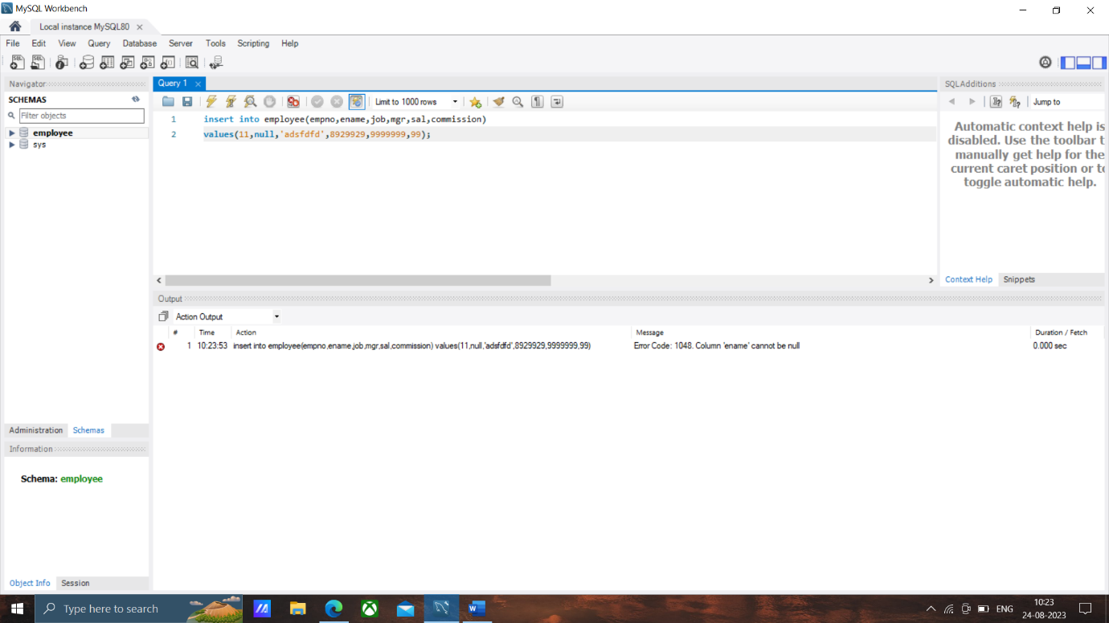

**QUESTION d**

alter table employee

add domian varchar(20);

**QUESTION e**

insert into employee(empno,ename,job,mgr,sal,commission)

values(2,'tu','meri',8929889,92299,9);

insert into employee(empno,ename,job,mgr,sal,commission)

values(2,'chaleya','mohabat',89229,99999,9);

insert into employee(empno,ename,job,mgr,sal,commission)

values(9,'phani','CEO',8929929,9999999,99);

**QUESTION f**

update employee

set job = 'founder'

where empno = 9;

**QUESTION g**

alter table employee

rename column empno to empid;

**QUESTION h**

delete from employee

where empid =1;

